Data Analysis of a Leading Brazilian

Retailer using SQL

2024

By Tejas Kale

Target is a globally renowned brand and a prominent retailer in the United States. Target makes itself a preferred shopping destination by offering outstanding value, inspiration, innovation and an exceptional guest experience that no other retailer can deliver.

This particular business case focuses on the operations of Target in Brazil and provides insightful information about 100,000 orders placed between 2016 and 2018. The dataset offers a comprehensive view of various dimensions including the order status, price, payment and freight performance, customer location, product attributes, and customer reviews.

By analyzing this extensive dataset, it becomes possible to gain valuable insights into Target's operations in Brazil. The information can shed light on various aspects of the business, such as order processing, pricing strategies, payment and shipping efficiency, customer demographics, product characteristics, and customer satisfaction levels. As a Data Analyst, Target want us to analyze the dataset to extract insights and provide actionable recommendations on whether **they should stay invested** in Brazil and if there is **any further growth opportunity.**

Business Case: Target SQL Project

**Problem Statement 1**: -

Import the dataset and do usual exploratory analysis steps like checking the structure & characteristics of the dataset.

1.1] **Tables present in dataset**

SELECT TABLE_NAME

FROM `Target.INFORMATION_SCHEMA.TABLES`

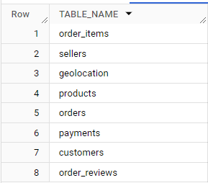

1.2] All Columns present in the dataset with Data type

SELECT column_name, data_type

FROM `Target.INFORMATION_SCHEMA.COLUMNS

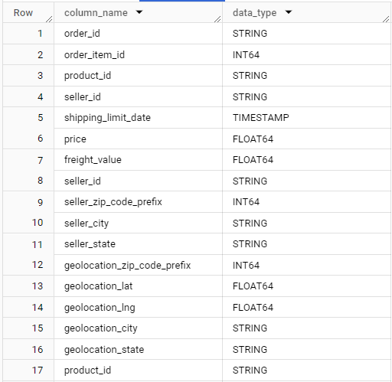

1.3] **Time range between which orders were placed**

SELECT

MIN(order_purchase_timestamp) AS start_date,

MAX(order_purchase_timestamp) AS end_date,

DATE_DIFF(MAX(order_purchase_timestamp), MIN(order_purchase_timestamp), day) AS days

FROM Target.orders



**Insights: -**

The first order was placed on “2016 – 09 – 04” and last order on “2018 – 10 – 17”. This tells we have data for 772 days.

1.4] **Count the Cities & States of customers who ordered during the given period**

SELECT COUNT(DISTINCT customer_state) AS state,

COUNT (DISTINCT customer_city) AS city

FROM `Target.customers` AS c

INNER JOIN `Target.orders` AS o

ON c.customer_id=o.customer_id



**Insights:** -

The query tells that customers from 27 different states and 4119 different cities have placed orders during given time period.

**Problem Statement 2**: -

In depth Exploration.

2.1] **Is there a growing trend in the no. of orders placed over the past years?**

GROWING TREND BY YEAR AND MONTH

SELECT

  EXTRACT(YEAR FROM order_purchase_timestamp) AS Year,

  EXTRACT(MONTH FROM order_purchase_timestamp) AS Month,

  COUNT(*) AS order_frequency

FROM Target.orders

GROUP BY 1, 2

ORDER BY 1, 2

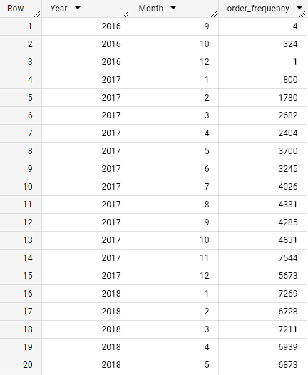

GROWING TREND BY YEAR

SELECT

  EXTRACT(YEAR FROM order_purchase_timestamp) AS Year,

  COUNT(*) AS order_frequency

FROM Target.orders

GROUP BY 1

ORDER BY 1

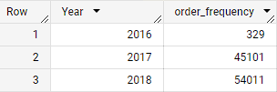

**Insights: -**

As evident from the yearly order table there is a significant increase in orders from 2016 – 2018 which is a positive sign that people are ordering more from e-commerce sites and rapidly gaining momentum.

2.2] **Can we see some kind of monthly seasonality in terms of the no. of orders being placed?**

SELECT

EXTRACT(MONTH FROM order_purchase_timestamp) as Month,

COUNT(*) AS Order_Freuency

FROM Target.orders

GROUP BY 1

ORDER BY 1

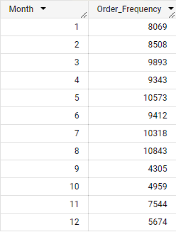

**Insights: -**

1. We can see significant no. of order placed from January to August. There is a sharp dip in no. of orders placed from September to December due to seasonal variations and the transition from Winter to Spring.

2. Highest no. of orders placed in May, July and August due to National holidays and Winter.

3. Additionally, significant shopping events like Black Friday and Christmas lead consumers to postpone purchases and wait for discounts and promotions.

**Recommendation: -**

1. The months from March to August give an opportunity to expand Target’s presence in Brazil as these are the months where there is increased e-commerce activity, providing offers and discounts, right marketing strategies to attract customers, and having a user-friendly interface for the customers to get notified about the deals and sale prices by following these practices Target can get maximum profit and become customers favorite.

2. The months from September onwards can be a crucial turning point as the e-commerce activity is low. Target can analyze the products that customers purchased the most and try to offer periodic discounts on them and can focus more on marketing and bring back-to-back cool offers so that customers continue to buy and they can retain the customers.

2.3] **What time do Brazilians tend to buy?**

WITH CTE AS(

  SELECT

  EXTRACT(HOUR FROM order_purchase_timestamp) AS hour,

  COUNT(*) AS count_of_orders

  FROM Target.orders

  GROUP BY 1

)

SELECT

CASE WHEN hour BETWEEN 0 AND 6 THEN "Dawn"

     WHEN hour BETWEEN 7 AND 12 THEN "Mornings"

     WHEN hour BETWEEN 19 AND 23 THEN "Afternoon"

     ELSE "Night"

     END AS time_of_day,

SUM(count_of_orders) AS orders_count

FROM CTE

GROUP BY time_of_day

ORDER BY 2 DESC

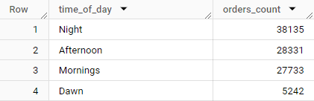

**Insights: -**

1. Sales are high in the Night,afternoon and morning when customers are most active in making orders, such as during office hours, night parties, or team lunch.

**Recommendations: -**

1. Increase service levels, discounts, staffing schedules, and customer engagement strategies during peak order placement times.

2. Target can also schedule targeted marketing campaigns and promotions to coincide with these peak periods, maximizing the impact of promotional efforts and driving sales.

3. In order to increase the orders in the morning and Dawn period Target can go with flash sales for 1 hour for specific items so that the order count can increase.

**Problem Statement 3**: -

Evolution of E-commerce orders in the Brazil region

3.1] **Get month-on-month no. of orders placed in each state**

SELECT c.customer_state,

  EXTRACT(MONTH FROM order_purchase_timestamp) AS month,

  COUNT(o.order_id) AS count_of_order

FROM Target.customers c

LEFT JOIN Target.orders o

ON c.customer_id = o.customer_id

GROUP BY c.customer_state, month

ORDER BY 1, 3 DESC

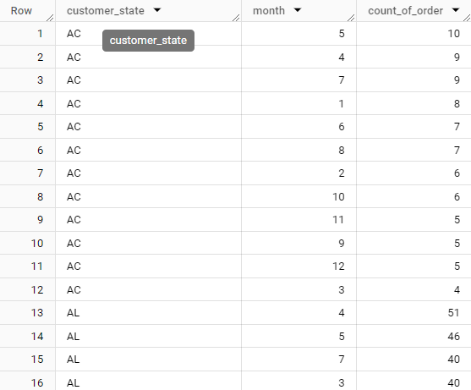

**Insights: -**

1. The order counts differ majorly from state-to-state **SP, RJ, MG, and BA** have consistent and good numbers of order counts, and throughout the year, there is not much variation which indicates the strong presence of e-commerce in these areas.

**Recommendation: -**

1. Target should focus more on the states which have a high level of sales such as the ones mentioned in insights these are states with a strong e-commerce presence and should focus on customer satisfaction.

2. Target should launch marketing campaigns and analyze customer requirements by doing surveys in the peak month of August which is the time when all the people buy the most therefore introducing offers, sales, and different marketing methods to gain a more customers.

3.2] **Orders count for top 10 cities with state**

SELECT c.customer_state, c.customer_city, COUNT(*) AS city_count

FROM `Target.customers` AS c

JOIN Target.orders AS o

ON c.customer_id = o.customer_id

GROUP BY c.customer_state, c.customer_city

ORDER BY city_count DESC

LIMIT 10

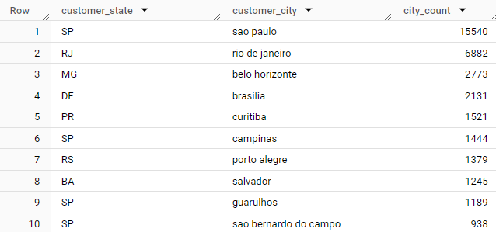

3.3] **Customer distribution across all states**

SELECT

  customer_state,

  COUNT(customer_unique_id) AS customers_distribution

FROM Target.customers

GROUP BY 1

ORDER BY 2 DESC

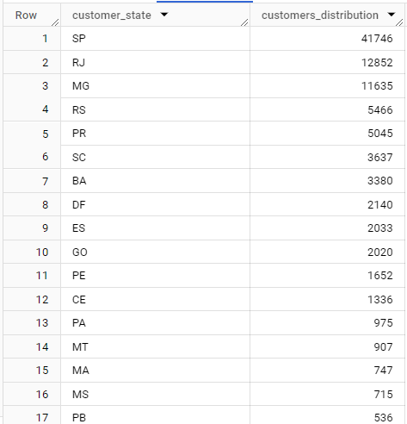

**Insights: -**

1. States like SP, RJ, and MG have the highest number of customers as the e-commerce presence is quite strong in these areas.

2. The states of AC, AP, and RR have the lowest count and the people are not so confident in e-commerce shopping.

**Recommendations: -**

1. To increase customer count for Target in the states of RR, AP, and AC in Brazil, implement targeted marketing campaigns, establish local partnerships, offer region-specific products, enhance the customer experience, and optimize the online presence with localized content and promotions. Understanding the local market is essential.

2. To increase customer count in RJ, MG, and SP, Target should prioritize improving the store experience, tailoring product selection and enhance online presence.

**Problem Statement 4**: -

**Impact on Economy: Analyze the money movement by e-commerce by looking at order prices, freight and others.**

4.1] **% increase in the cost of orders from year 2017 to 2018 (include months between Jan to Aug only)**

WITH total_payment_2017 AS (

  SELECT

    SUM(p.payment_value) AS total_2017

  FROM Target.payments AS p

  JOIN Target.orders AS o

  ON p.order_id = o.order_id

  WHERE EXTRACT(YEAR FROM order_purchase_timestamp) = 2017

  AND EXTRACT(MONTH FROM order_purchase_timestamp) BETWEEN 1 AND 8

),

total_payment_2018 AS (

  SELECT

    SUM(p.payment_value) AS total_2018

  FROM Target.payments AS p

  JOIN Target.orders AS o

  ON p.order_id = o.order_id

  WHERE EXTRACT(YEAR FROM order_purchase_timestamp) = 2018

  AND EXTRACT(MONTH FROM order_purchase_timestamp) BETWEEN 1 AND 8

)

SELECT

  total_payment_2017.total_2017,

  total_payment_2018.total_2018,

  ROUND(((total_payment_2018.total_2018 - total_payment_2017.total_2017) * 100 / total_payment_2017.total_2017), 2) AS percent_increase

FROM

  total_payment_2017,

  total_payment_2018;



**Insights: -**

1. There is around 137% increase in the cost of orders from previous years we can conclude that e-commerce is rapidly growing in Brazil.

2. The higher cost of orders indicates increased demand and potentially higher average order values.

3. E-commerce growth can be attributed to several factors, including improved internet access, increased smartphone penetration, convenience, a wider range of products, and competitive pricing. As more people embrace online shopping and businesses expand their digital presence, the e-commerce industry in Brazil is likely to continue growing.

**Recommendation: -**

1. Improve the online shopping experience with a user-friendly interface and efficient checkout process.

2. Enhance customer service through prompt responses and personalized assistance.

3. Strengthen marketing efforts to increase brand visibility and attract more customers.

4.2] **Total & Average value of order price for each state**.

SELECT c.customer_state,

  ROUND((SUM(p.payment_value)),2) AS Total,

  ROUND((AVG(p.payment_value)),2) AS Average

FROM Target.customers c

JOIN Target.orders o

ON c.customer_id = o.customer_id

JOIN Target.payments p

ON o.order_id = p.order_id

GROUP BY c.customer_state

ORDER BY Total DESC, Average

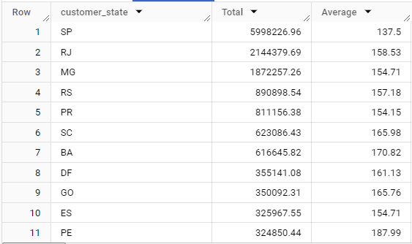

**Insights and Recommendation on order price: -**

1. Average Order Value: The average price across different customer states varies significantly, ranging from 137.5 (SP) to 191.48 (PB). Target could focus on increasing the average order value by implementing strategies such as upselling, cross-selling, and offering bundled or complementary products

2. Regional Opportunities: Identify states with higher average prices and lower competition, such as PB (191.48) and AL (180.89). Target could strategically target these regions with tailored marketing campaigns and promotions to attract customers who are willing to spend more, potentially increasing sales and profitability.

4.3] **Total & Average value of order freight for each state**

SELECT c.customer_state,

  ROUND((SUM(freight_value)),2) AS Total_freight,

  ROUND((AVG(freight_value)),2) AS avg_freight

FROM Target.customers c

JOIN Target.orders o

ON c.customer_id = o.customer_id

JOIN Target.order_items ot

ON o.order_id = ot.order_id

GROUP BY c.customer_state

ORDER BY 2 DESC

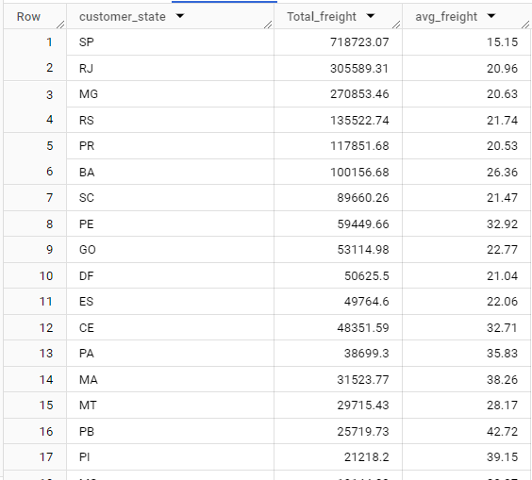

**Insights and Recommendation on order price and order freight: -**

1. Freight Costs: The average freight value also varies across states, with RR having the highest average at 42.98 and SP having the lowest at 15.15. Target could optimize logistics and negotiate better shipping rates to reduce freight costs, which would make their products more attractive to customers and potentially increase sales.

2. Customer Retention: Analyze customer behavior in each state to identify opportunities for improving customer retention. For instance, states like MG and RJ have significantly higher sums of prices and freight values, indicating potential loyal customer bases. Target could implement loyalty programs, personalized offers, and exceptional customer service to retain customers in these regions and encourage repeat purchases.

**Problem Statement 5**: -

Analysis based on sales, freight and delivery time

5.1] **Delivery time and the difference between the estimated & actual delivery date**

SELECT order_id,

  DATE_DIFF(order_delivered_customer_date, order_purchase_timestamp, DAY) AS delivery_time_taken,

  DATE_DIFF(order_delivered_customer_date, order_estimated_delivery_date, DAY) AS diff_estimated_delivery

FROM `Target.orders`

WHERE order_delivered_customer_date IS NOT NULL AND

      order_purchase_timestamp IS NOT NULL

ORDER BY order_purchase_timestamp

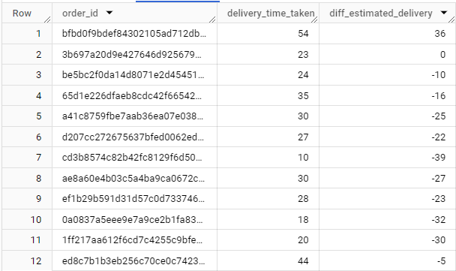

**Insights: -**

1. Positive sign in diff_estimated_delivery column indicates that order is delayed by that no. of days, Negative sign indicates that order is delivered before than estimated date by that no. of days.

Whereas, 0 indicates that order delivered on time.

2. Understanding the delivery time helps evaluate the speed of order processing and shipping, while the delivery delay highlights deviations from expected delivery timelines.

**Recommendation: -**

1. Optimize logistics operations, streamline order processing workflows, and enhance delivery speed and reliability.

2. Prioritize proactive communication with customers regarding delivery updates and potential delays to manage expectations and mitigate dissatisfaction.

5.2] **Delivery Performance - LATE, EARLY, ON TIME**

WITH CTE AS (

SELECT order_id,

  DATE_DIFF(order_delivered_customer_date, order_purchase_timestamp, DAY) AS delivery_time_taken,

  DATE_DIFF(order_delivered_customer_date, order_estimated_delivery_date, DAY) AS diff_estimated_delivery

FROM `Target.orders`

WHERE order_delivered_customer_date IS NOT NULL AND

      order_purchase_timestamp IS NOT NULL

ORDER BY order_purchase_timestamp

)

SELECT order_id,

      CASE WHEN diff_estimated_delivery < 0 THEN "early_delivered"

       WHEN diff_estimated_delivery > 0 THEN "late_deliverd"

       ELSE "timely_delivered"

       END AS delivery_performance

FROM CTE

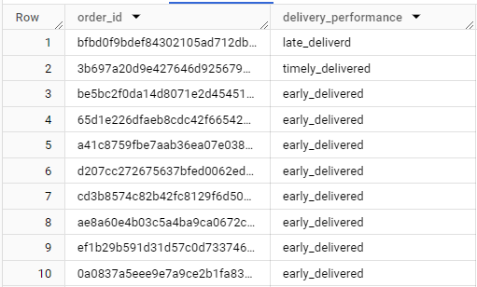

 5.3] **Top 5 states with the highest & lowest average freight value**

# Highest

SELECT c.customer_state,

  AVG(ot.freight_value) AS freight_price

FROM Target.customers c

JOIN Target.orders o

ON c.customer_id = o.customer_id

JOIN Target.order_items ot

ON o.order_id = ot.order_id

GROUP BY c.customer_state

ORDER BY freight_price DESC

LIMIT 5

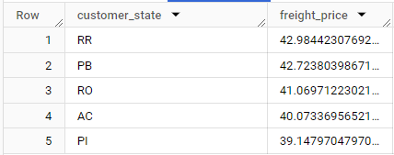

# lowest

SELECT c.customer_state,

  AVG(ot.freight_value) AS freight_price

FROM Target.customers c

JOIN Target.orders o

ON c.customer_id = o.customer_id

JOIN Target.order_items ot

ON o.order_id = ot.order_id

GROUP BY c.customer_state

ORDER BY freight_price ASC

LIMIT 5

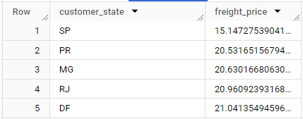

**Insights: -**

1. RR and SP have the highest and lowest average freight values among all the states.

2. Due to the shipping may be disproportionately high, transportation infrastructure limitations or supplier constraints in high average freight values.

3. With lowest average freight values may indicate opportunities for cost savings and operational improvements through route optimization or carrier negotiations.

**Recommendation: -**

1. Implement targeted strategies to mitigate high shipping costs and improve freight efficiency.

2. Target can explore alternative transportation modes, and negotiate bulk shipping discounts.

3. Monitor freight costs over time, identify cost-saving opportunities

4. Higher skilled Logistic Specialist to solve delivery problem.

5.4] **Top 5 states with the highest & lowest average delivery time**

# SLOWEST DELIVERY STATE

SELECT customer_state,

  ROUND((AVG(DATE_DIFF(order_delivered_customer_date, order_purchase_timestamp, day))),2) AS delivery_days

FROM `Target.orders` o

JOIN `Target.customers` c

ON o.customer_id = c.customer_id

GROUP BY c.customer_state

ORDER BY 2 DESC

LIMIT 5

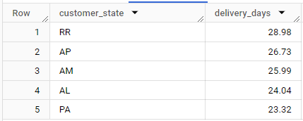

# FASTEST DELIVERY STATE

SELECT customer_state,

  ROUND((AVG(DATE_DIFF(order_delivered_customer_date, order_purchase_timestamp, day))),2) as delivery_days

FROM `Target.orders` o

JOIN `Target.customers` c

ON o.customer_id = c.customer_id

GROUP BY c.customer_state

ORDER BY 2 ASC

LIMIT 5

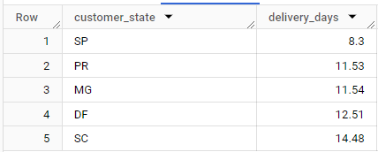

**Insights: -**

1. RR have the highest average delivery time and SP have lowest average delivery time among all the states.

2. Maybe the variations in shipping speed, and transportation infrastructure.

3. Average freight price and average delivery days are linked to each other.

**Recommendations: -**

1. Optimize logistics operations, reduce transit times, and enhance delivery reliability.

2. Target can collaborate with shipping partners to implement route optimization algorithms, track delivery performance metrics, and invest in technology solutions.

3. Try to minimize the delivery days and maximize the high service standards.

5.5] **Top 5 states where the order delivery is really fast as compared to the estimated date of delivery**

#TOP 5 Fastest delivery states

SELECT c.customer_state,

  ROUND((AVG(DATE_DIFF(order_estimated_delivery_date, order_delivered_customer_date, day))),2) AS HowFast_than_Estimated

FROM `Target.customers` c

JOIN `Target.orders` o

ON c.customer_id = o.customer_id

GROUP BY c.customer_state

ORDER BY 2 DESC

LIMIT 5

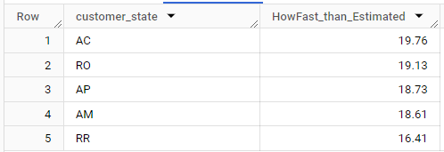

#TOP 5 Slowest delivery states

SELECT c.customer_state,

  ROUND((AVG(DATE_DIFF(order_estimated_delivery_date, order_delivered_customer_date, day))),2) AS HowFast_than_Estimated

FROM `Target.customers` c

JOIN `Target.orders` o

ON c.customer_id = o.customer_id

GROUP BY c.customer_state

ORDER BY 2 ASC

LIMIT 5

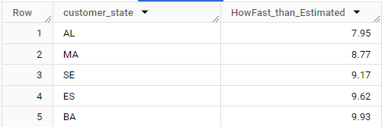

**Insights: -**

1. On an average, AC state has a faster delivery than the estimated delivery date.

2. On an average, AL state has a slower delivery than the estimated delivery date.

3. Due to operational excellence, effective supply chain management, and high levels of customer satisfaction.

**Recommendation: -**

1. Improve the delivery speed performance and replicate successful strategies across regions.

2. Invest in training programs to empower employees and enhance delivery capabilities.

3. Take the customer feedback and improve delivery speed, ensuring consistent service excellence and customer delight.

4. Target should hire a team of Transportation Specialist to care of Logistics and Supply Chain Management.

**Problem Statement 6**: -

**Analysis based on the payments**

6.1] **month on month no. of orders placed using different payment types**

SELECT

  FORMAT_DATE('%Y-%m', order_purchase_timestamp) AS year_month,

  p.payment_type,

  COUNT(*) AS order_count

FROM `Target.orders` o

JOIN `Target.payments` p

ON o.order_id = p.order_id

GROUP BY year_month, p.payment_type

ORDER BY year_month, 3 DESC

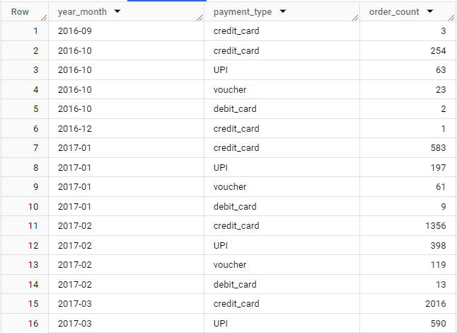

**Insights: -**

1. We can observe a similar trend in the no. of order placed using different Payment Type for each month. People preferring Credit Card more as compared other Payment Type followed by UPI and Debit Card. The reason could be the easy availability of EMI option.

2. In 2017 and 2018, fewer orders are placed through the debit card.

**Recommendation: -**

1. Target should explore further more collaboration with BNPL/Banks, etc. as people preferring Credit card for the transaction more.

2. Target can adopt digital payment solutions and improve checkout experiences.

6.2] **no. of orders placed on the basis of the payment installments that have been paid**

SELECT p.payment_installments,

  COUNT(DISTINCT o.order_id) AS order_count

FROM `Target.payments` p

JOIN `Target.orders` o

ON p.order_id = o.order_id

GROUP BY 1

ORDER BY 1

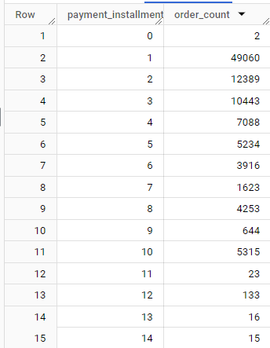

**Insights: -**

1. For one payment installment option more orders are placed and for 23 installment options, fewer orders are placed.

2. Different payment installment options reflect consumer preferences for flexible payment terms, budget management, and affordability.

**Recommendations: -**

1.. Provide exclusive promotions, discounts, or incentives for customers who choose installment plans, encouraging them to opt for this payment method.

2. Empower customers by allowing them to customize their payment schedules and choose payment options that suit their needs.

3. By providing flexible payment options and incentives, you can increase e-commerce sales for Target and attract customers who may have been hesitant to make larger purchases.

6.3] **Average payment value based on payment type**

SELECT payment_type,

  ROUND((AVG(payment_value)),2) AS avg_payment

FROM `Target.payments`

GROUP BY 1

ORDER BY 2 DESC

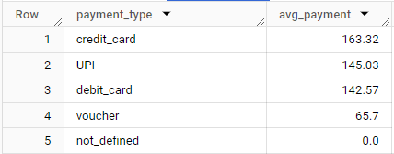

**Insights: -**

1. Here not defined indicated failed payment. Fortunately, all payments were successful.

2. Average payment using Credit Card is significantly higher followed by UPI and Debit Card.

**Recommendation: -**

1. Target should explore further more collaboration with BNPL/Banks, etc. as people preferring Credit card for the transaction more.

2. Target can adopt digital payment solutions and improve checkout experiences

**SUMMARY**

**Key Insights: -**

1. There is a Growing trend in the no. of orders being placed from 2017 to 2018 and Highest no. of orders placed in May, July and August due to Winter season and National holidays. A dip in sales can be seen from September to December. A rise in sales can be seen from March to August.

2. More sales are made in the afternoon, morning and night; dawn has the least sales.

3. The order counts differ majorly from state-to-state **SP, RJ, MG, and BA** have consistent and good numbers of order counts, and throughout the year, there is not much variation which indicates the strong presence of e-commerce in these areas.

4. There is a 137% increase in the cost of orders from previous years we can conclude that e-commerce is rapidly growing in Brazil.

5. RR and SP have the highest and lowest average freight values among all the states.

6. Orders for states like AP, and RR take a long time to deliver.

7. People preferring Credit Card more as compared other Payment Type followed by UPI and Debit Card. The reason could be the easy availability of EMI option.

**Recommendation: -**

1. Introducing seasonal/new inventory to lower the impact of the decrease in sales from September.

2. Offering discounts for dawn timings to increase sales.

3. For states like Roraima, and Paraíba with high freight value we can increase the delivery substations to decrease the delivery cost.

4. We can boost the delivery of Amapá, Roraima-like states by changing the means of transportation.

5. As the highest amount of transactions are done through credit cards, we can partner with credit card companies to give special offers to our customers, so that we can increase our sales.

6. A significant amount of people are paying in 1 to 10 installments, which means maybe a lot of people are getting paid on a monthly basis. We can partner with NBFCS and banks to offer them cheap loans, so that they can spend more

7. Target should work on discount pricing strategies before the peak seasons to acquire new customers from the northern regions of Brazil where the customer count is very low, retain the customers in the southern parts of the state, increase sales, and promote new products. This will multiply the profit that Target normally make

8. Target has to develop a good social omnipresence. It should have footprints across all social media platforms to reach new potential customers and sellers. Since the count of customers and sellers is very less in most of the northern regions of Brazil

9. We can see how the orders trajectory is showing a very abrupt increase in orders volume within a very short time. Looking at the overall trend, it is seen that business is picking up very fast in Brazil so companies have to be ready with extra workforce. To avoid high risk, it can consider hiring contractual employees

10. Avg delivery time is quite high for most of those states from where the company is receiving quite less volume of orders, detailed study is needed further for checking the other reasons behind such low volume of orders from majority of states. Huge delivery time can be one of the reasons and we need to work on it.

11. Hiring a Transportation Specialist team, Logistics Specialist, Supply Chain Analyst can optimize delivery times, reduce costs, and improve customer satisfaction in Brazil.